The histological effects of zinc oxide nanoparticles on the kidney of adult male rabbits
Hekmet O Abdel-Aziz,Eman E Ragab, ,Hagar M Hamdan
Ass.Prof. of Histology, Faculty of Medicine, Sohag University
Lectuer of Histology, Faculty of Medicine, Sohag University
MD.of Histology, Faculty of Medicine, Sohag University
Abstract:
Introduction: The growth of Nanotechnology in the past few years changes every aspects of human life. Today, nanoparticles are used in personal care products, cosmetics, sunscreens, and in biomedicine as drug delivery system and for therapeutic purposes. Among the most common nanotechnology in consumer and medical products are zinc oxide nanoparticles (ZnO NPs). Most applications of ZnO NPs exploit the reactivity of the oxide, as a precursor to other zinc compounds. They are widely used as drug delivery vehicles, anticancer agents, components of the restorative dental and food packaging materials, and as cosmetic, antiseptic, and ultraviolet protection products (sun screen). Exposure to ZnO NPs could occur in the industrial settings and through everyday consumer products.
Aim of the work: Our aim was to study the histological changes in the kidney of adult male rabbit after administration of different doses of ZnO NPs.
Materials and method: Our study was carried out on 15 adult male rabbits. The animals were divided into three groups randomly. Group Ι: kept without treatment as control group. Group Π: were received ZnO NPs by intraperitonial injections in a dose of 100ml/kg(0.4 cm of prepared solution) once daily for 14 days. Group ΠΙ: were received ZnO NPs by intraperitonial injections in a dose of 250ml/kg (1cm of prepared solution) once daily for 14 days. The rabbits were sacrificed on the fifteenth day of the experiment, kidneys of each animal were obtained and stainrd by Hx&E.
RESULTS: ZnO NPs have had a prominent toxic effects on kidney tissue. There were destruction of proximal convoluted tubules inform of loss of brush border, vacuolation of cytoplasm and intratubal protein deposition. Also the renal corpuscles showed congestion and dilation of glomerulus.
Conclusion: ZnO NPs causes histopathological changes of the kidney through oxidative stress. These may give us more information on hazards of ZnO NPs on human health.

Introduction
Nano-revolution impacts on every aspect of our life, medical, science, drug applications, and defense industries (Long and Ye, 2007). Nanoparticals (NPs) exposure is rapidly increasing led to a growing concern on the bioavailability and toxicity of NPs (Igarashi, 2008).
ZnO NPs are one of the most toxic metallic NPs.This due to its higher ability to shed ions and its high solubility(Watson et al., 2014).ZnO NPs produced marked cytotoxicity in several types of cell lines, as well as an apparant activation of signal transduction pathways induce apoptosis (Sharma et al., 2012,a).
Toxicity includes cytotoxic, genotoxic, and proinflammatory effects. ZnO NPs induce oxidative damage through reactive oxygen species (ROS) so it triggered mitochondrial mediate apoptosis. High dose of ZnO NPs could cause nephrotoxicity and alternation in kidney metabolism in experimental animal (Sharma et al., 2012,b).
Mitochondria are considered target organelles for cytotoxic injury. They have a critical role in maintaining cellular functions favoring aerobic ATP production. In addition to supplying cellular energy. The mitochondrion is one of the major cell targets for ZnO NPs-induced ROS and the intrinsic mitochondrial apoptotic pathway has an important role in ZnO NPs-induced cell death. Once ZnO NPs reach the mitochondria, they can generate mitochondrial ROS via impaired electron transport chain and depolarize mitochondrial membrane can catalyze the generation of superoxide (O2)either by accelerating electron transfer to molecular oxygen or blocking the electron transport chain of mitochondria (Xiao et al., 2016).
Materials and methods
Animals:
The present study was set on 15 adult male rabbits (obtained from the animal house of Sohag University), weighing from 1.5 to 2 kg. They were housed in clean properly ventilated cages under the same environmental conditions with free access to food and water throughout the whole period of experiment.
Chemicals:
Zinc oxide nanoparticle (>100nm) powder was obtained from Sigma-Aldrich chemicals. 60 gram of the powder was dissolved in 220 cc of normal saline and dispersed by ultrasonic vibration for 15 min.
Experimental design:
The Institutional Animal Care and the Research Ethics Committee of the Faculty of Medicine, Sohag University, Egypt, approved the experimental protocol.
The animals were divided into three groups randomly, 5 animals in each:
Group Ι: kept without treatment as control group.
Group Π: were received ZnO NPs by intraperitonial injections in a dose of 100ml/kg(0.4 cm of prepared solution) once daily for 14 days.
Group ΠΙ: were received ZnO NPs by intraperitonial injections in a dose of 250ml/kg (1cm of prepared solution) once daily for 14 days.
Methods:
The rabbits were sacrificed on the fifteenth day of the experiment after being anaesthetized by ether. Kidneys and both femur of each animal were obtained.
Kidneys were fragmented from 0,5-1,0 cm in thickness, renised in saline and fixed in 10%formalin for 24 hours. The preserved organs were processed, dehydrated with alcohol, cleared with xylol, infiltrated and embedded with paraffin wax. Paraffin wax blocks were sectioned at 5μ thick with a rotary microtome using disposable blade. Sectioned slides were stained for
Light microscopy:
- Haematoxylin and Eosin for general structure
Results:
Hematoxylin and eosin stain of control group: showed that the kidney was modified into cortex and medulla. The cortex is the outer zone and composed of renal corpuscles (Bowman’s capsule and glomerulus) and renal tubules proximal convoluted tubule (PT) and distal convoluted tubule (DT). PT was identified by its narrow lumen, number of cell in section about 3 to4 cells and the apical part of the cell has brush border. Both PT &DT were lined by simple cuboidal epithelium and had basal striation. Renal medulla was composed of collecting tubule and loop of Henles (Fig.1).
Low dose treated group
Sections of (group II) revealed histological changes as compared to the control group. The renal corpuscles were more or less similar to the normal with no changes. While there were disturbance in renal tubules .There were loss of their brush bored in large number of PT (Fig.2). There was vacuolation of the cytoplasm of some tubules; there was destruction of some of DT with dense nucleus(Fig.3).
High dose treated group
revealed more histological changes than the previous group. There were increase in the bowman’s space with intact partial layer and congestion of intraglomerular capillaries (Fig.15). Proximal tubules lost their brush border and there was vacuolation of their cytoplasm (Fig.13&14). There was destruction of some of DT (Fig.13). Also there were infiltrations of inflammatory cells and capillaries congestion in between tubules (Fig.16). There was intra tubular protein deposition (Fig.13).

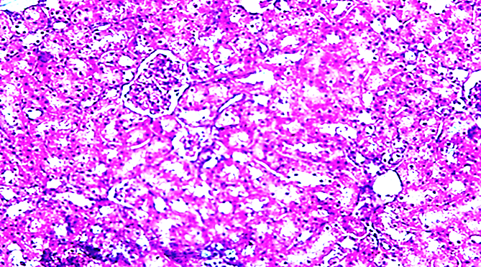

Fig(1): A photomicrograph of the control kidney showing, the normal architectuer of the kidney.the renal corpusles composed of glomerulus (G) and surrounded by bowmans capsule.the renal tubules modified into proximal (P ) and distal (D) tubule(H&E 200).
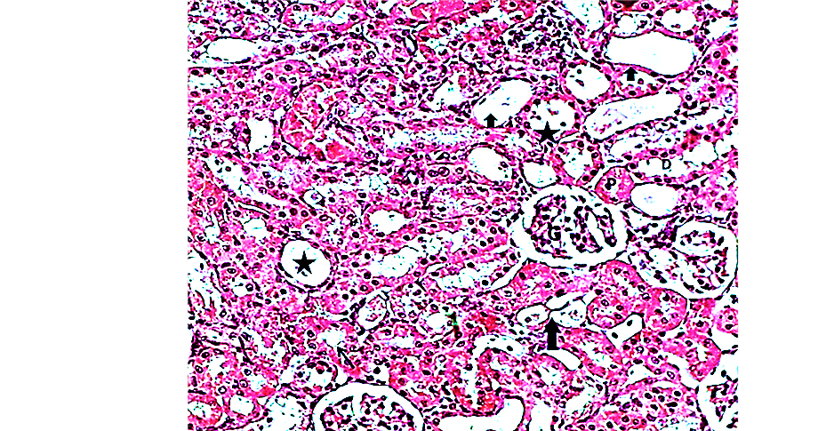
Fig(2): A photomicrograph of the kidney treated by(100mg/Kg of ZnO NPs) showing ,some of PT loss their brush border(stars), However some of them still have brush border (arrow) and some of DCT their nucleus appear dense (arrow heads) (H& E 200).
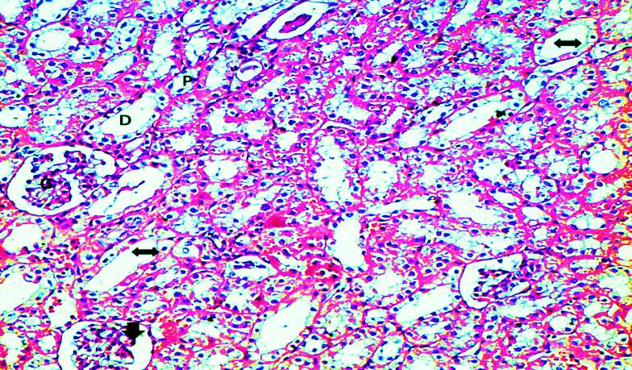
Fig. (3): A Photomicrograph of the kidney (treated by 250mg/Kg of ZnO NPs) showing PCT loss their brush border and there is vacuolation of their cytoplasm (left-right arrows), and increase the bowman’s space with intact parietal layer with congestion of intraglomerular capillaries (arrow head) (H & E 200).

Discussion
NPs show high rate of bio distribution than ordinary particles .Single dose of ZnO NPs (20-100nm) when intraperitoneally administrated at dose (2.5 g/kg) resulted in accumulation of ZnO NPs in different organs. Concentrations of ZnO NPs in the organs were higher after administration of similar amounts of ZnO particles (Li et al., 2012).
ZnO NPs have two major routes of elimination from the circulatory system through bile in the faeces or through the kidneys in the urine. Cho et al. (2013) who indicated that the zinc concentration in the urine of ZnO NPs treaedt groups significantly increased in a dose dependent manner. The exposure route influenced the rate of ZnO NPs clearance as ZnO NPs injected into the peritoneum persisted in the serum for a longer period of time than those administered orally (Li et al., 2012).
ZnO NPs are one of the most toxic metallic NPs.This due to its higher ability to shed ions and its high solubility(Watson et al., 2014).ZnO NPs produced marked cytotoxicity in several types of cell lines, as well as an apparant activation of signal transduction pathways induce apoptosis. On the other hand, exposure to ZnO NPs shows a genotoxic potential mediated by lipid peroxidation and oxidative stress (Sharma et al., 2012,a).
The most prominent result in our study was loss of brush border of PCT. That was obviously appeared in our sections. These agree with lin et al. (2016) who founded histopathological changes of the kidneys in form of tubular dilatation, loss of brush borders and flattening of tubular epithelium in mice treated by ZnO NPs. This explained by ZnO NPs induce cytotoxicty and genotoxicity in kidney epithelial cells, as ROS generation and apoptosis may be the intrinsic reasons for the high toxicity (Uzar et al., 2015).
We observed also other signs of degenerations of the epithelial cells of renal tubules in the form of cytoplasmic vacuolation. This agrees with Tang et al. (2016) who found cytoplasmic vacuolation and swelling of the liver cell and renal tubules epithelial cells in the rat treated with 600 mg/kg of Zno NPs.
In our study, there were prominent intra tubular homogenous acidophilic depositions that appeared in sections. This agrees with Ben-Slama et al. (2015) who describe these homogenous accumulations as intra tubular protein deposition. But other study they consider these homogenous accumulations as hemorrhage inside renal tubules.
In addition, there was apparent blood congestion in between tubules and intraglomerular capillaries. This result was supported by Ben-Slama et al., (2015) who noticed appearance of sinusoidal congestion, RBC deposition in the liver veins.
ZnO NPs had a severe renal toxicological effect and led to increase of blood biochemical markers (blood urea nitrogen and creatinine) suggested the renal dysfunction (Najafzadeh et al., 2013).Thus we concluded that high dose of ZnO NPs lead to its accumulation in kidney and cause renal structureal damage.

Conclusion: ZnO NPs have had cytotoxic effect on the kidney in dose dependent manner.
References:

1-Ben-Slama I, Mrad I, Rihane N, Mir LE, Sakly M, et al (2015): Sub-Acute Oral Toxicity of Zinc Oxide Nanoparticles in Male Rats. J Nanomed Nanotechnol 6: 284.
2-Cho WS, Duffin R, Bradley M, Megson IL, MacNee W, Lee JK, Jeong J, Donaldson K. (2012): Predictive value of in vitro assays depends on the mechanism of toxicity of metal oxide nanoparticles. Part Fibre Toxicol; 10-55.
3- Igarashi E. (2008): Factors affecting toxicity and efficacy of polymeric nanomedicines. Toxicol. Appl. Pharmacol. 229 (1), 121-134.
4-Long, X.F., Ye, Z.G. (2007): Relaxor behavior in Ba (Zn1/3Nb2/3)O-3-PbTiO3 new solid solution. IEEE Trans. Ultrason. Ferroelectr. Freq. Control 54 (12), 2595-2598.
5-Li C, Shen C, Cheng Y, Huang H, Wu C, Kao C, Liao J, Kang J.(2012): Organ bio distribution, clearance, and genotoxicity of orally administered zinc oxide nanoparticles in mice. Nanotoxicology; 6:746–756.
6-Lin Y, Chiu I, Cheng F, Lee Y, Wang Y, Hsu Y et al.(2016): The role of hypoxia-inducible factor-1alpha in zinc oxide nanoparticle-induced nephrotoxicity in vitro and in vivo. Part Fibre Toxicol :13-52.
7-Najafzadeh H, Ghoreishi S, Mohammadian B, Rahimi E, Afzalzadeh MR, Kazemivarnamkhasti M, Ganjealidarani H. (2013):Serum biochemical and histopathological changes in liver and kidney in lambs after zinc oxide nanoparticles administration, Vet World 6(8): 534-537.
8-Sharma V, Anderson D, Dhawan A. (2012,a): Zinc oxide nanoparticles induce oxidative DNA damage and ROS-triggered mitochondria mediated apoptosis in human liver cells (HepG2). Apoptosis; 17:852–870.
9-Sharma V, Singh P, Pandey A, Dhawan A. (2012,b): Induction of oxidative stress,DNA damage and apoptosis in mouse liver after زsub-acute oral exposure to zinc oxide nanoparticles. Mutat Res 745: 84-91.
10-Tang H, Min X, Qian R, Ru-Wen J, Qi-Ji L, Ying-Lun L. (2016): The effect of ZnO nanoparticles on liver function in rats .Int J Nanomedicine. : 4275–4285.
11-Uzar N, Abudayyak M, Akcay N, Algun G, Ozhan G. (2015): Zinc oxide nanoparticles induced cyto- and genotoxicity in kidney epithelial cells. Toxicol Mech Methods; 25:334–9.
12-Watson C, Ge J, Cohen J, Pyrgiotakis G, Engelward BP, Demokritou P. (2014):.High-throughput screening platform for engineered nanoparticle-mediated genotoxicity using Comet Chip technology. ACS Nano; 8:2118–2133.
12-Xiao L, Chunhua L, Xiaoniao C, Zhuo Y. (2016): Zinc oxide nanoparticles induce renal toxicity through reactive oxygen species, Food and Chemical Toxicology 90-102echnology. ACS Nano; 8:2118–2133.

التاثيرات النسيجيه لجزيئات اكسيد المتناهيه الصغر علي كلي ذكور الارانب البالغه

مقدمه:
لقد شهدت تكنولوجيا الجزيئات المتناهيه الصغر تطور كبير في السنوات القليلة الماضية مما ادي ال تغيرات في جوانب الحياة البشرية المختلفه. اليوم . حيث يتم استخدام هذه الجزيئات في مجال منتجات العناية الشخصية ، ومستحضرات التجميل ، واقيات الشمس ، وايضا في مجال صناعه االدواء ولأغراض علاجية. ومن بينهذه الجزيئات المتناهيه الصغر جزيئات اكسيد الزنك المتناهيه الصغر وهي تعد الأكثر شيوعًا في صناعه المنتجات الاستهلا كية والطبية ، جزيئات أكسيد الزنك المتناهيه الصغر تستخدم على نطاق واسع في مجال مضادات للسرطان ، ومكونات مواد تجميل وايضا كماده خافظه المواد الغذائية ، ، بالابضافه الي دورها الفعال في الوقايه من الأشعة فوق البنفسجيه.لذلك يمكن التعرض لهذه الجزيئات بسهوله في البيئات الصناعية ومن خلال استخدام المنتجات الاستهلاكية اليومية.
الهدف من العمل:
كان هدفنا هو دراسة التغيرات النسيجية في كلية أرنب الذكور البالغين بعد إعطاء جرعات مختلفة من جزيئات اكسد الزنك المتناهيه الصغر
. ادوات و طرق اابحث
لقد تم تقسيم خمسة عشر من ذكورالارانب البالغه بالتساوي إلى ثلاث مجموعات تتكون كل منها من (5)
المجموعة الأولى: المجموعة الضابطه
. المجموعة الثانية :المجموعة المعالجة التي تم معالجاتها بالجرعات المنخفضة، حيث تم حقن الأرانب في الغشاء البريتوني بجزيئات اكسيد الزنك المتناهيه الصغر (100 ملغ / كغ / يوم) لمدة 14 يوما.
المجموعة الثالثه : المجموعه التي تم معالجتها بالجرعة العالية، حيث تم حقن الأرانب داخل الغشاء البريتوني بجزيئات اكسيد الزنك المتناهيه الصغر (500 ملغم / كغم / يوم) لمدة 14 يوم.
في نهاية التجربة،تم تخدير الارانب و تشريح اجسامهم لاخذ عينه نسيجية من الكلي .و تم عزل نخاع العظام لدراسة السميه الجينيه .
النتائج :
لقد تبين من فحص عينات الكلي ان جزيئات اكسيد الزنك المتناهيه الصغر لها اثار سميه علي نسيج الكلي .حيث اظهرت العينات تدمير في النسيج الطلائي المبطن لانابيب الكلي.فقد اختفت الزغيبات الموجوده في خلايا انابيب الكلي .وكما ظهر ايضا انتفاخات و فراغات متقطعه في سيتوبلازم الخلايا المبطنه للانابيب .وكما حدث تكدس للماده الجينيه للنواه نتيجه للاثار السميه الجينيه لجزيئات اكسيد الزنك المتناهيه الصغر..
و اظهر فحص العينات ايضا وجود احتقان في الاوعيه الدمويه المغذيه لنسيج الكلي .وزياده االياف الكولاجين بين انابيب الكلي وحول الاوعيه الدمويه الموجود داخل حويصله بومان. .
لذلك ينبغي اخذ الحذر من استخدام جزيئات اكسيد الزنك في المركبات التي يمكن ان تصل الي جسم الانسان عبر الطرق المختلفه حتي لا تتسبب في تلف خلايا الكلي .
.

